**Javascript Assignments Output Screen**

Program No 1

Write a JavaScript program to calculate multiplication and division of two numbers (input from user).

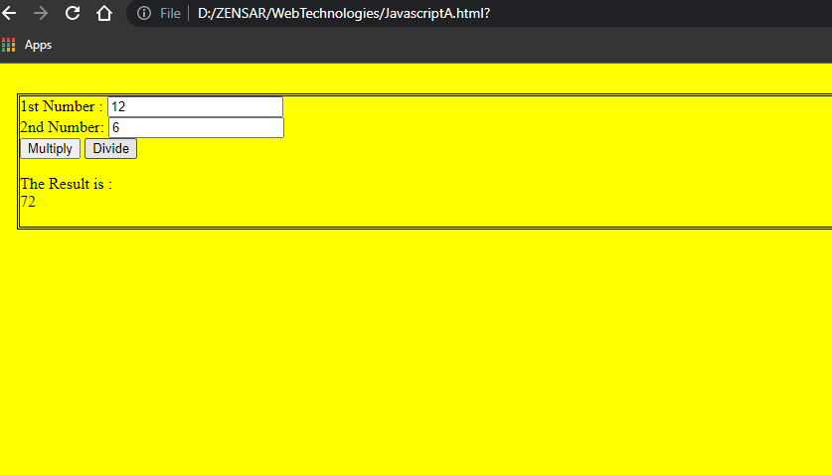

<!DOCTYPE html>

<html>

<head>

<style type="text/css">

body {

margin: 30px;

}

body:hover {

background-color: yellow;

}

body{

border-style:;

}

</style>

</head>

<body>

<form>

1st Number : <input type="text"

id="firstNumber" /><br>

2nd Number: <input type="text"

id="secondNumber" /><br>

<input type="button" onClick="multiplyBy()"

Value="Multiply" />

<input type="button" onClick="DivideBy()"

Value="Divide" /><br>

</form>

<p>The Result is : <br>

<span id = "result"></span>

</p>

<script>

function multiplyBy()

{

num1 = document.getElementById(

"firstNumber").value;

num2 = document.getElementById(

"secondNumber").value;

document.getElementById(

"result").innerHTML = num1 * num2;

}

function DivideBy()

{

num1 = document.getElementById(

"firstNumber").value;

num2 = document.getElementById(

"secondNumber").value;

document.getElementById(

"result").innerHTML = num1 / num2;

}

</script>

</body>

</html>

Program No 2.   
Write a JavaScript to get the extension of a filename given by the user(hint: use split and pop()

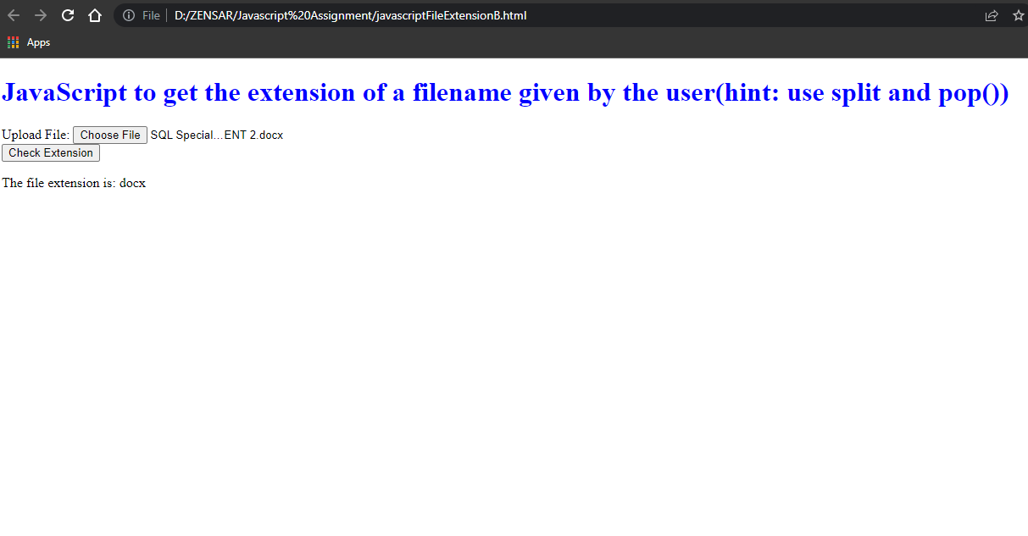

<!DOCTYPE html>

<html>

<head>

<title>File Extension using Javascript</title>

<style type="text/css">

h1{

color:blue;

}

</style>

</head>

<body>

<h1>JavaScript to get the extension of a filename given by the user(hint: use split and pop())</h1>

<div>

<form>

Upload File: <input type="file"

id="file1" />

<br>

<input type="button" value="Check Extension" onclick =

"checkFileExtension();"/>

</form>

</div>

<p id="result">The file extension is: <span class="output"></span></p>

<script>

function checkFileExtension()

{

fileName = document.querySelector('#file1').value;

extension = fileName.split('.').pop();

document.querySelector('.output')

.textContent = extension;

};

</script>

</body>

</html>

Program No 3.

Write a JavaScript program to compute the sum of the given two integers. If the two values are same, then returns triple their sum.

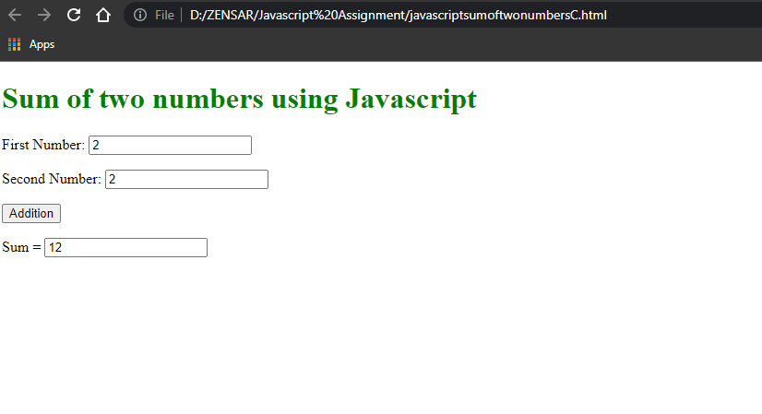

<!doctype html>

<html>

<head>

<style>

h1{

color : green;

}

</style>

</head>

<body>

<script>

function Addition()

{

var num1, num2, sum;

num1 = parseInt(document.getElementById("first").value);

num2 = parseInt(document.getElementById("second").value);

if(num1 == num2)

{

sum = 3 * (num1 + num2);

document.getElementById("answer").value = sum;

}

else

{

sum = num1 + num2;

document.getElementById("answer").value = sum;

}

}

</script>

<h1>Sum of two numbers using Javascript</h1>

<p>First Number: <input id="first"></p>

<p></p>Second Number: <input id="second"></p>

<button onclick="Addition()">Addition</button>

<p>Sum = <input id="answer"></p>

</body>

</html

Program No 4.  
Write a JavaScript program to check whether two given integer values are in the range 50..99 (inclusive). Return true if both of them are in the said range, else false.  
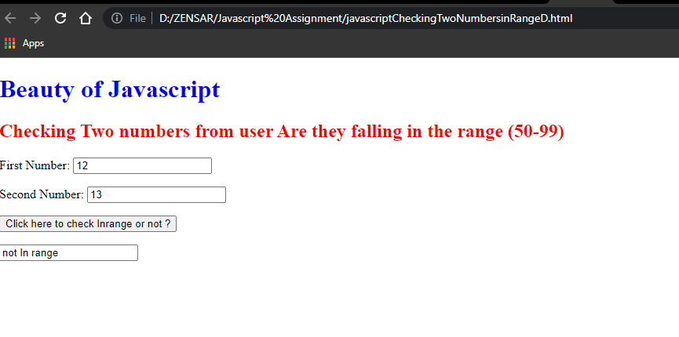

<!doctype html>

<html>

<head>

<style>

h1{

color : blue;

}

h2{

color : red;

}

</style>

</head>

<body>

<script>

function range()

{

var x, y;

x = parseInt(document.getElementById("first").value);

y = parseInt(document.getElementById("second").value);

if ((x >= 50 && x <= 99 && y >= 50 && y <= 99) )

{

inrange = "In THe range";

document.getElementById("answer").value = inrange;

}

else

{

inrange = "not In range";

document.getElementById("answer").value = inrange;

}

}

</script>

<h1 float:centre; >Beauty of Javascript</h1>

<h2>Checking Two numbers from user Are they falling in the range (50-99)</h2>

<p>First Number: <input id="first"></p>

<p></p>Second Number: <input id="second"></p>

<button onclick="range()">Click here to check Inrange or not ?</button>

<p> <input id="answer"> </p>

</body>

</html>